
ACTIVITY 2
WRITING
Your teacher has already played a POWERPOINT presentation about the importance of TOURISM in Seychelles.
The presentation gave you some information about what tourists bring to our country.
- Foreign currency. Dollars, Euros and Pounds which we then use to pay for things we need from other countries.
- Jobs. Thousands of people in Seychelles have work because of tourism.
- A greener environment. We work hard to keep our environment healthy. One reason for this is to attract tourists. Most tourists come to Seychelles because of our beautiful environment.
Seychelles offers many more things than just its beautiful environment however. Here are some pictures of just some of the things that visitors can enjoy here. And we can too!
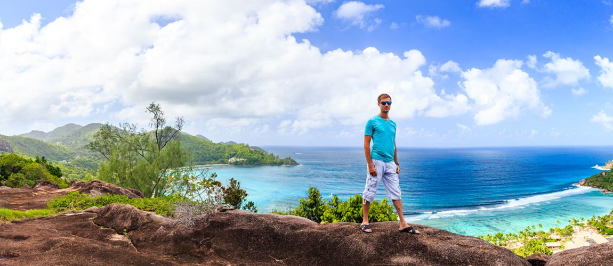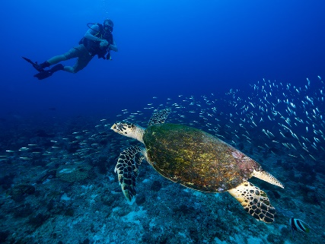


THERE ARE TWO PARTS TO THIS ACTIVITY
Part 1:
Imagine that you are working for the Seychelles Tourism Board and your job is to MARKET Seychelles all around the world. This means that you have to use WORDS and PICTURES to make people want to visit Seychelles and enjoy a fantastic holiday here.
There are THOUSANDS of other places in the world which also want to attract tourists so your job is to make sure that Seychelles looks and sounds FANTASTIC.
You have been asked to invent a new SLOGAN – a short phrase which will persuade people in other countries to visit Seychelles.
Your slogan has to be SHORT but at the same time it must SAY A LOT about what Seychelle shas to offer.
So you have been asked to write THREE different slogans and this is your first task today. You can get some ideas from the PowerPoint, your own experiences of living here, and also the pictures above.
Your teacher can send your ideas to us and who knows – yours might even be chosen to promote Seychelles in the future!
Part 2:
Write a short essay about why tourists are important to Seychelles.
You will have some ideas from watching the PowerPoint earlier.
You can also get some ideas from this activity sheet (CLUE – they are near the top of the first page…)
HOW LONG SHOULD YOUR ESSAY BE?
Between 100 and 200 words. That might sound like too many but don’t worry, if you plan your work carefully it will be easy.
PLANNING
Here are some tips on how to create an interesting piece of writing….
It is important to know what you are going to write about before you begin.
Make a LIST of the main points you are going to make, for example the money which tourists bring to Seychelles.
Decide which ORDER you are going to write about your points.
Try and do some RESEARCH (this is where you find out things which can make your writing more interesting and your message more powerful. For example you might find out how much money tourism brings to Seychelles in a ‘normal’ year (NOT this one!)
Think about your VOCABULARY. Try and use some powerful words, particularly DESCRIPTIVE words (adjectives). For example the phrase ‘It is a nice looking beach’ is boring. ‘It is a stunning mixture of bright hot sand and lush cool water’ is more interesting don’t you think?
Finally you can write your CONCLUSION. This is where you sum up the main points of your essay without repeating what you have said before. Tricky!
Once again, your teacher can send us your work and we will be very happy to read it.

