
ACTIVITY ONE
ART & DESIGN
WELCOME TO THE SEYCHELLES!
You will need to work with a partner for this activity.
WHAT YOU ARE GOING TO DO
You are going to create a WELCOME message for tourists coming to Seychelles
This will be a painting or coloured drawing and it will only have ONE WORD, which is WELCOME. Everything else that you want to say has to be done using pictures.
The art work will feature YOU!
HOW WILL YOU DO IT?
LESSON 1
- Working with your partner BRAINSTORM the following question: Why do tourists come to Seychelles?
Write down as many reasons as you can think of. Here are three to get you started:
SUNSHINE BEAUTIFUL ENVIRONMENT FRIENDLY PEOPLE
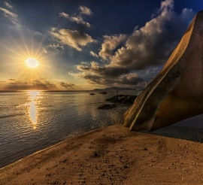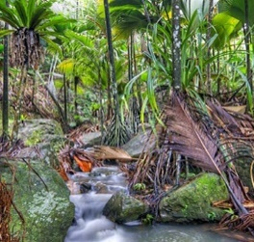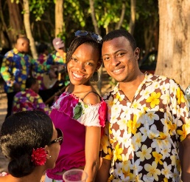
Try to think of at least 20 things which makes Seychelles special for tourists

- Now, make a DRAWING of your partner. He or she should be smiling. Then swap around so that your partner draws you. When you are being drawn imagine that you are WELCOMING someone to your country. You might wave, or put your arms together in greeting. Think carefully about how you are going to POSE for your partner’s drawing. WHEN THE DRAWINGS ARE FINISHED SWAP THEM AROUND!


- So now you are going to add to the drawing your partner made of you. First add the word WELCOME somewhere on your drawing
- Next choose FIVE of the things which you listed when you did the BRAINSTORMING activity. Then, for HOMEWORK, try and find as many of them as you can, either for real, or in a picture. If you have the internet you can make a drawing of your chosen object, looking carefully at the screen and drawing what you can see. If you have a printer you can just print it out. You might need to ask for help from your family. Bring your objects and pictures to school ready for the next lesson.

LESSON 2 + – Make sure that you remember to bring your homework objects and pictures

- Draw each of your chosen things onto your picture, placing them next to your body and head.
- When you have finished you will have a drawing which might look something like this…..
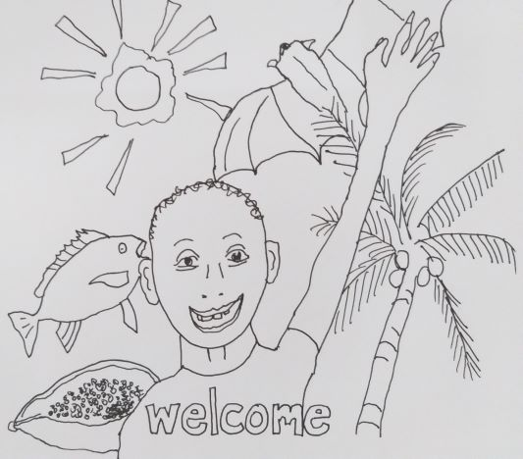
- NOW you can decide whether to colour it in OR paint it. Don’t forget to colour or paint the background – perhaps a wonderful blue sky with fluffy clouds (but no rain…) It might take several lessons to finish adding the colour….
- This will FINISH the art work.
WHAT HAPPENS NEXT?
Your work can be displayed in your school.
Also, your teacher can send a picture of your finished art work to the Tourism Club Coordinator, Mrs Testa. We can then make some PRINTS of the best ones and display them at the AIRPORT, the JETTY and some of our lovely HOTELS….. So real tourists will see your work and feel WELCOME!
There will be a great prize for the artists who made any pictures used in this way.
So…get busy, get thinking and GOOD LUCK with your art project.




